**A Novel Approach for Preliminary Research and Development in Sensitive Fields**

Anonymous for Submission

First Department Name, First Institution/University Name, City, State, Country, email@email.com

Anonymous for Submission

Second Department Name, Second Institution/University Name, City, State, Country, email@email.com

Anonymous for Submission

Second Department Name, Second Institution/University Name, City, State, Country, [email@email.com](mailto:email@email.com)

Anonymous for Submission

Second Department Name, Second Institution/University Name, City, State, Country, [email@email.com](mailto:email@email.com)

Anonymous for Submission

Second Department Name, Second Institution/University Name, City, State, Country, [email@email.com](mailto:email@email.com)

**ABSTRACT**

Although an increasing number of UK citizens require food-aid to survive, fundamental social, financial, and logistical problems exist in the food-charity sector. Lack of communication between supermarkets, local authorities, and food-aid users, results in a loss of autonomy for food-aid recipients. We demonstrate an altered user-centred design process, developing a low-fidelity interactive prototype. Utilising secondary research and HCI development tools reduce the need for initial user consultation, proving invaluable within areas where user contact may not be possible or requires discussion of sensitive subjects. The process outlined allows researchers to undertake further initial work, approaching users at more appropriate developmental stages, prompting more actionable feedback. The approach improves the sustainability of HCI methods in an inhibited social climate. Our contribution is two-fold, providing the groundwork for an integrated system tackling several issues within the food aid provision sector, whilst documenting a development method complimentary to those requiring user consultation.

**CCS CONCEPTS**

• Human Computer Interaction (HCI) • Interaction Design • Electronic Commerce

**KEYWORDS**

Food Poverty, Application, Human Centered Design, Prototyping, Visual Storytelling, Food aid, Agile, Social Change

1. **Introduction**

This paper focuses on the initial development stages of a food aid platform, designed to build upon existing relationships between food aid charities and supermarkets [1] allowing for collaboration between the local authority, food banks and local supermarket branches. As food aid is a sensitive area, it is difficult to establish relationships to allow for user research due to the stigma associated with food aid use, this lack of user interaction is then exacerbated with the ongoing COVID-19 pandemic which limits face-to-face interaction. This paper outlines how the preliminary design process was the ‘*user research*’, undertaken using existing social research and charity reports, were used to guide a user-centred agile development approach. This included user needs establishment, persona creation, design fictions and concluded with the development of a low-fidelity interactive prototype via Balsamiq Cloud, to motivate user feedback at a later stage.

1. **Design Process**

As user-centred design holds many of the agile development principles at its core, the researchers selected the stages of Agile Development to mark the activities the project would go through. As this report details a prototype, the Discovery and Alpha stages of the design process will be the focus of the report.

The *Discovery Stage* Activities include: User Research (primarily derived from literature due to the Covid-19 crisis), User needs, User Wants, a confirmation of System Requirements from these and a Design Fiction.

The *Alpha Stage* Activities include: User Journey mapping, sketches of UI design and a Low Fidelity prototype outlined later in this report Including images of the activities the researchers undertook, and some considerations for future stages of development. These include a discussion of beta and live considerations for the final product.

1. **Discovery Phase**
   1. **Literature Review**

Due to the nature of the task, and the remote-working conditions, it became evident that any user needs, and user stories would have to be derived from literature on the topic. This included looking at studies performed regarding food poverty and food aid in the UK, and the main influencers when it comes to food poverty and consumption in the UK. These issues were then adopted as user needs.

This literature review was primarily derived from the individual work performed prior to this project and was used during a brainstorming session to discuss what user needs would be adopted into our personas. Figure 1 (left) shows the initial discussion of the aspects we derived from this literature, in addition to the original design fictions we established from our individual work. Consequently, this allowed us to solidify our user needs.

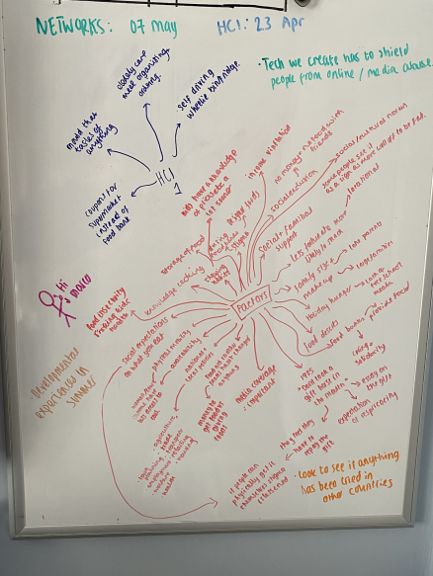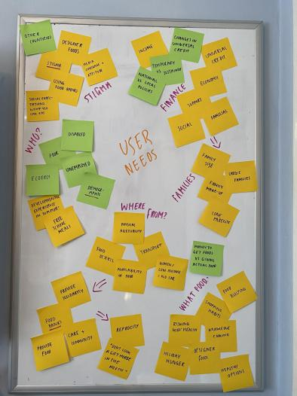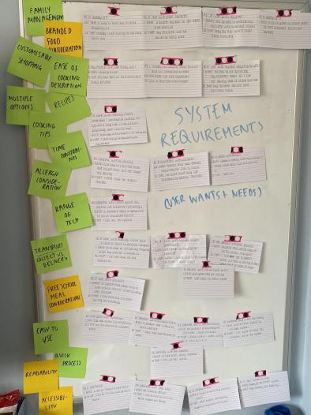

**Figure SEQ Figure \* ARABIC1: Stages of user research. Left: literature review findings. Centre: user needs establishment. Right: System requirement identification via user wants and needs.**

* 1. **User Needs**

As Human Centred Design is built around the users, it is imperative to identify the specific needs of our intended users so as to provide the most relevant and effective product for them to use. The primary method of finding user needs was through literature review; various sources we collectively reviewed indicated a series of needs. The user needs can be seen in Figure 1 (centre), with the system requirements taken from it shown in Figure 1 (right).

With this in mind, the researchers created a series of personas and ‘user want statements’ to critically identify what exactly the user would want from the product we had theory-crafted. These were created prior to our work on the prototype as it offered an invaluable insight into how the users would need our prototype to look and what features would be important to include. This essentially helped us to develop what would become the final prototype.

With further reference to the ‘user want statements’ these were written with a specific format in mind, which helped us to efficiently identify and correlate user needs: “**As a** [who it was that needed something], **I/We need** [what they needed], **so that** [the reason behind the need]”, shown in Figure 2.A close up of a sign

**Figure SEQ Figure \* ARABIC2: User Wants and Needs statements**

* 1. **Personas**

As a first step in the design process we opted for the persona method, i.e.: describing a fictional character that will help us identify the user needs [3]. These characters, based on case studies[4], charity campaign reports[4][5][6] and literature[7][**?????**] included:

1. James Harrington: A 28-year-old disabled man, unemployed and reliant on public transport, he lives with his part-time employed partner.
2. Mary Juniper: a 44-year-old single, unemployed mother of 4 with no personal transport. Concerned children will face difficulties at school if their friends become aware of food bank reliance.
3. Georgie Jackson: a 17-year-old boy, recently vacating his family home due to a poor circumstances.
   1. **Establishing Requirements**

Although Figure 4 shows a very visual version of the requirements, the main requirements for the system can be broken up into four groups: Functional requirements, non-functional requirements, usability requirements, and (due to the nature of the application and its partnership between the charity and the supermarket) cross functional requirements. These requirements can be seen in appendix A.1

* 1. **Mission Statement**

A mission statement was outlined for the prototype technology in order to highlight the aim of this to the researchers and maintain focus and clarity of the prototype to be developed. The mission statement is not solely for the use of the researchers, but also can be communicated to any potential stakeholders in order to succinctly explain the technology and is shown below:

*“Our food aid delivery service helps those in need who want autonomy over their food choices; by facilitating food aid and integrating it into traditional online grocery systems unlike current food-aid provision.”*

* 1. **Design Fiction**

As part of our design process, we created the following design fiction, shown in Figure 3, for our proposed product. As design fictions can be used for many differing areas in research [4], lacking the ability to get user feedback the researchers used this design fiction to try and consider what the reaction of users would be to the product. And the differing reactions they may have once the product is in use.

The format of a customer review was selected as it could consider different personalities and their reaction to the product. There are many important aspects that this design fiction highlights, including perception, presentation and expectation. The design fiction allowed the concept of user expectation to be explored, given that users typically associate application interaction with profit-seeking business rather than charitable efforts; they may have a different set of expectations with regards to their user experience, which would likely be communicated through user reviews.

**Figure SEQ Figure \* ARABIC3: Design fiction**

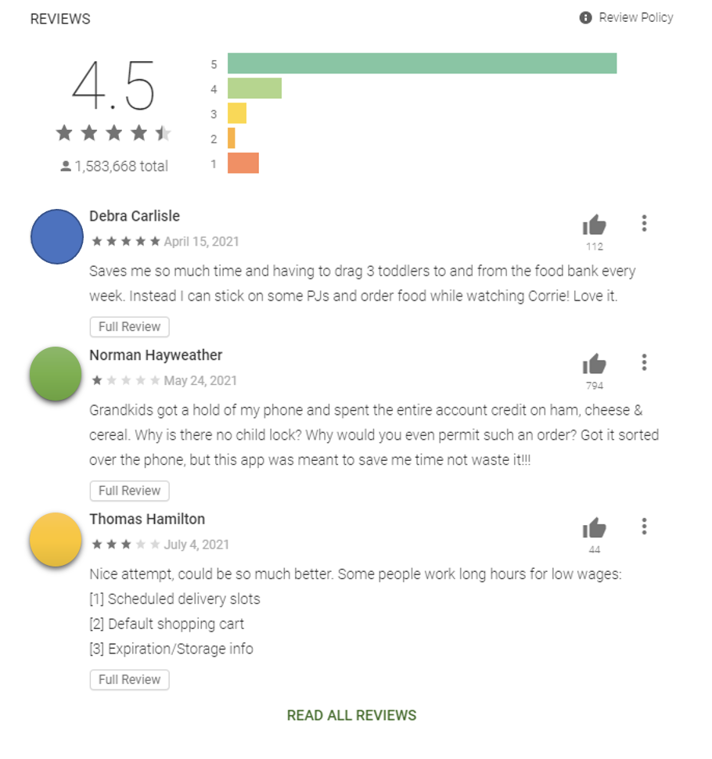

1. **Alpha Stage (Prototyping)**

Three main steps were involved during the Alpha Stage of development. These included solidifying the user journey through the system, sketching initial ideas of both the UI and different aspects the system will include, and then creating the low-fidelity interactive prototype.

* 1. **User Journey**

For the purposes of this project, a user journey was created (Figure __). the user journey aided in development of the low fidelity project. firstly, by defining the limits of the system. It is important to lay out what the system will achieve and ensure that functionality is being provided to fulfil this expectation. Secondly, depict how the user will navigate and interact with the system. Ensuring that the system is able to perform to an adequate degree, accomplishing the overall purpose of a food aid platform.

Establishing a user journey of the system is crucial to developing a suitable prototype, highlighting the usage of key functionality the system offers [A.R. 1]. Whilst this user journey is specific in what is interacted with and as can be seen in later sections of this paper, there is more interactive features and navigation which the user may alternatively utilise. This specific user journey was crucial in the development of the low fidelity interactive prototype since this project focuses on the Minimal Viable Product (MVP).

A user journey was developed by the researchers in order to define limits of the system and assist the researchers in envisaging a specific user journey (Figure 4, left).

Establishing the user journey through the system is a key aspect in the development of a prototype. This is for a number of reasons including establishing the main functionality that will be interacted with during use of the system [5]. Although other navigation options are available during the user’s interaction with the system, it can be seen in the following section that this specific user journey was crucial in the development of the low fidelity interactive prototype as this project focuses on the Minimal Viable Product (MVP).

**Figure SEQ Figure \* ARABIC4: Left: User journey. Right: Initial sketches of the prototype.**

* 1. **Sketches**

The sketches that were created following the user journey mapping, were not meant to be a high-quality artistic piece (as no initial design should be). They were intended to offer a preliminary insight into the application. The sketch, shown in Figure 4 (right), was created during the initial brainstorm of the product and included aspects such as selecting by recipe and by product. This feature then became a focal point in the prototype. This sketch was designed to outline how some parts could be used to meet user needs and give an initial concept of the design used to create the prototype layout.

* 1. **Low-Fidelity Interactive Prototype**

The many design decisions detailed previously, were then merged together to create the first, low fidelity, prototype. This prototype was created using an online tool, Balsamiq Cloud [2] which allows for the creation of wireframe prototypes but has the functionality to allow the user or presenter to navigate through the system using buttons; in order to fully appreciate the demonstration of the product.

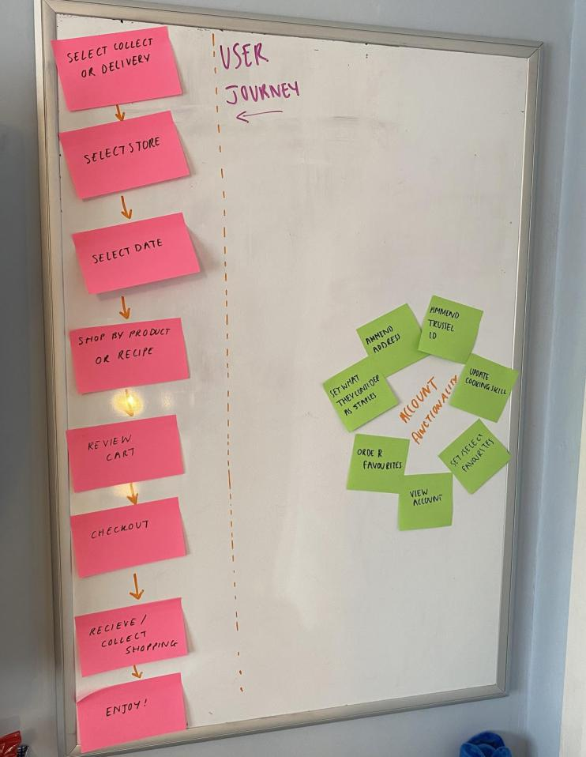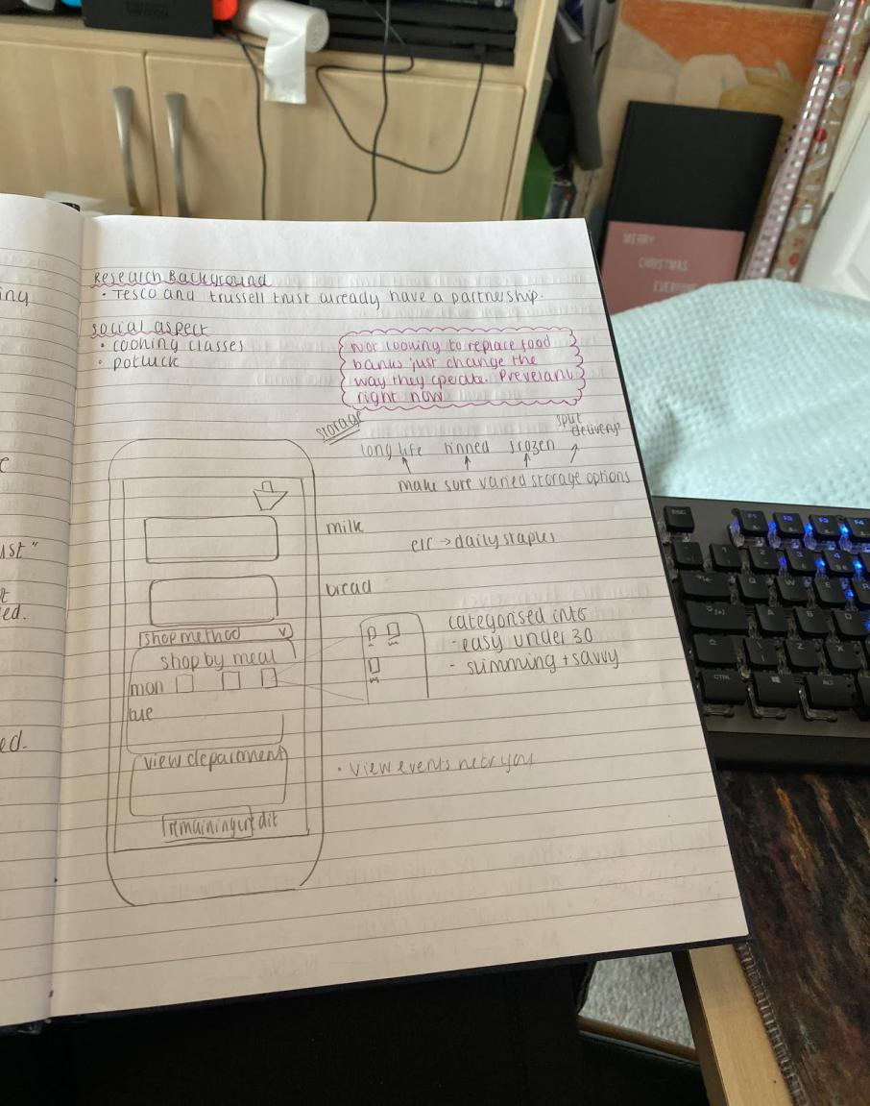

The system allows users to select their shopping, based on both recipes and household staples, and order that shopping for delivery or collection from their local supermarket, via either an application or a web page. This purchase is then charged to their food-aid provider / local authority account. There will be check mechanics ensuring that enough food is purchased to feed all family members nutritious meals and ensure that they have household essentials, such as: cleaning products, washing products and sanitary products. The system will not allow the user to procure non-essential items such as alcohol or cigarettes, to ensure that the food aid provider and local government funds are not being misused.

Figures 5 shows screen captures of the different elements of the prototype. Both web and mobile versions have been considered due to user’s accessibility and device compatibility requirements. Further, an accessibility button can be seen throughout the prototype, allowing the user to access functions, such as the “read aloud” feature for text, subtitles videos or text in simplified English.

Another noteworthy feature is that, throughout the shopping experience, the user can shop by both recipe and regular shopping items. The system will prompt the shopper to remember their household staples, to ensure that they make the most of the system on offer; ensuring that each household has enough food to put on the table.

The system also provides the user with a nutritional breakdown of the foods that they have ordered, and recipes to go alongside the food they have ordered. Justification for many of the prototype’s features can be seen within the following section, where it is linked to academic literature.

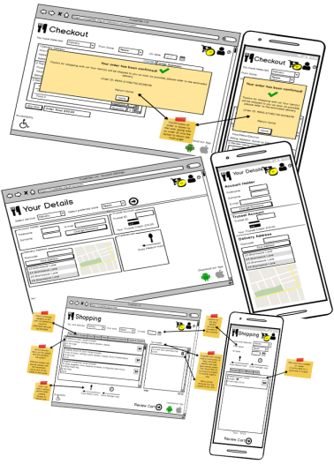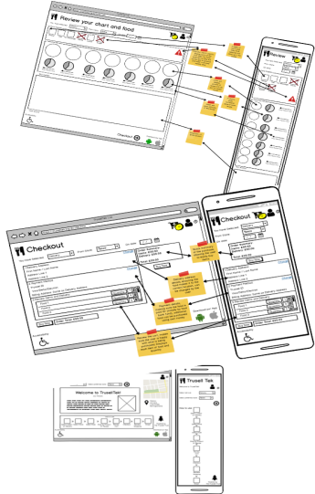

**Figure SEQ Figure \* ARABIC5: Screenshots of low-fidelity prototype.**

1. **Literature-Prototype relationship**

As previously mentioned, the prototype and requirements developed in order to complete this aim, were based on research reviewed by the researchers within previous works. Due to this, the prototype developed has a close relationship to relevant food poverty research.

The proposed system addresses several issues regarding the sustainability [6] and responsiveness to demand [7] of current food bank operations; in contrast, supermarkets are already equipped to deal with large numbers of shoppers. The integration of this system within the current food bank / food aid system, would allow for decreased running costs within the organisation. As the food aid trust would have reduced running costs, having reduced the need for warehouses and refrigeration units, budget could be reallocated to provide food for more people. As food bank use has been increasing [8], partly due to the changes in universal credit [9], having provisions and systems in place prior to food aid reaching or exceeding its capacity, would prevent individuals from being unable to eat.

The application also addresses complex issues surrounding free school meals. As children in large families are more likely to experience poverty [10], children leaving school for the holidays can cause an additional strain on families. This is extremely pertinent in the current climate with local authorities having to step in making food parcels for these children in need as the schools experienced emergency closures. These free school meal parcels have since been replaced by a voucher scheme, with a partnership between the government and supermarkets [11]. This vital emergency arrangement, in addition to the existing relationships between some supermarkets and food aid organisations [12] shows that partnerships can be created with supermarkets to provide aid highlighting the feasibility of implementing a system such as that detailed in this pictorial

As nutrition is directly linked with health [13], it is important that individuals get the nutrition that they require. As many individuals, for varying reasons [14][15], struggle to prepare foods with high nutritional value, the application’s nutrition summary and cooking tips will assist them. Furthermore, the application will allow them to develop cooking skills and understand nutrition. Although discussed briefly as part of the prototype, this could be explored further in future iterations of the system.

The application, by offering both collection and delivery, allows for flexibility for those who may otherwise struggle with acquiring foods themselves. As can be seen from the user wants and system requirements, having options between collection and delivery was integral as not everyone has the ability to visit the supermarket. This can be for a number of reasons. Principally, there is the financial aspect; as it can be assumed that most, if not all individuals using this service are experiencing financial difficulty, Consequently, they may not be able to afford transport or have access to a car [16]. There is also the fact that if individuals have decreased mobility, it can significantly affect their ability to visit food banks [9], increasing their difficulty in getting food in addition to their financial difficulty. It is also stated in the literature that single parents can struggle to get their food when trying to travel with their children [15]. This option is also vital for those that live in ‘food deserts’ as they may not normally have supermarkets that offer nutritious and fresh foods [14].

The literature also highlights many psychological impacts that food poverty can have on individuals. These included the stigma of using food banks [14][15]. This system addresses this issue by the defining concept that, although this is a food aid service, it is in partnership with the supermarkets allowing for discretion; not showing that these individuals are accessing the food aid. Another aspect that it considers is allowing individuals to select branded foods for their children so that they do not experience food bullying [17] from their peers due to the types of food they consume. Due to consumer materialism and the perceived class difference regarding food that can be consumed by different parties [18], food bullying is a significant problem in childhood groups [19] and can have a significant impact on children’s mental health [22] therefore, as food insecurity already has an impact on mental health in children [23], any steps that the system can take to prevent this have the potential to make a real difference to children’s lives.

The proposed technology allows users to exercise choice within their food purchases; restoring a sense of agency that a person may have lost through experiencing food poverty [24]. Given that the proposed technology provides users with an element of “buying power” through providing them with the means to purchase their own food; they are less likely to “feel” poor, given that they are not the recipients of food donations in a more traditional way. Research has shown a potential link between perceived socio-economic status and obesity, experimental conditions showed participants consuming more calories when made to feel poor [25]. Considering this, the researchers believe that the technology could improve the health of recipients; this would have additional benefits to healthcare services [24][25].

1. **Critical Reflection**

The following section aims to critically evaluate the designed and prototyped technology with regards to its ability to address a social change challenge.

Whilst the technology cannot be fully evaluated by its ability to affect social change due to not progressing beyond the interactive prototype stage; the technology has a strong grounding in research surrounding the topic. The prior section highlights the effectiveness of the technology to combat some of the issues present in the food aid space. The proposed technology considers several issues with traditional food aid provisions, aiming to provide a novel solution to a multi-faceted problem. The technology is able to demonstrate this capability due to a thorough consideration of appropriate research.

This system, although a prototype, has the potential to establish real change in communities and in disadvantaged areas. As stated by [26] ‘Hunger is a national crisis’, therefore despite designing this prototype for a local authority, the problem of food poverty is on a national scale. However, according to [27], the North of the UK seems more affected by this issue than the South. This increases the criticality with which a system such as this is needed in the North East areas, but the system does have the potential to make real change in a country in which food aid as a national issue.

The technology is able to reduce stigma surrounding the use of food banks by removing the requirement to attend a food bank in person. Removal of this requirement could be seen to increase the number of people who may be reluctant to seek assistance due to the potential stigma. To ensure that the system does not negatively impact the state of individuals using the service, the media surrounding the system’s use and creation will have to be controlled. If this system is seen to be an attempt to cover up the very real issue of food poverty, it could cause a detrimental area of social change and make people’s perceptions of food poverty and food aid to be worse than they are at present; thus, , causing more stigma and ensuring even fewer people access the system.

One aspect that the system does not consider is that of local businesses. When promoting a partnership between large scale supermarket corporations, issues may occur with local stores. Local businesses make up several donations that currently take place in food banks, and that gives them an inferred role in the societal responsibility of helping one another. Thus, moving such a relationship to be strictly with large scale supermarkets could create a diminished footfall for small businesses. Hereby, negatively affecting one subset of the constituency to help another: creating a negative media perception for both the local authority and local government.

Given that the system is online, there may be issues with accessibility for users who are technically illiterate; those who require digital assistance must not be excluded from accessing the food aid they require [28]. Given that the technology has the potential to reduce financial burden on food bank charities through a reduced need to maintain physical spaces, the charities could develop a digital assistance programme; helping those who require help with technology gain familiarity with the system. Such a digital assistance programme could take the form of digital skills workshops or one-to-one in-home visits from charity workers, not only covering use of the application, but a broad range of digital technologies.

The development of this prototype and the methods via which it was undertaken, provide a novel contribution to the field of HCI, showing the value of secondary data when producing early research and prototypes in stigmatised or sensitive topics. Although this does mitigate the use of user interaction in the field, it does promote sustainability of existing HCI methods and allows for preliminary investigations in an area which can promote effective social change. Although the validity of the extent of social change can only be determined with future user feedback on the prototype, the approach detailed in this paper shows that secondary research can provide a novel approach to research, complimentary to those that include user interaction - hereby suitable for the current social climate, or when researching sensitive areas.

1. **Conclusion**

Overall, this application satisfies the needs of multiple stakeholders. It meets the local authority’s need of providing a digital resource to address food poverty, with the current climate resulting in local authorities being overwhelmed with individuals requiring food aid and being unable to leave the house, the system can aid both in the short and long term. The system also meets the needs of the users, having been explored extensively as part of the secondary data and literature seen in this study, by providing a wide range of functionality to allow them to receive their shopping the most convenient and discreet ways possible. The process documented in this paper is designed to run in a complimentary fashion to those that incorporate users.

Although the system does have downsides and areas where it may not meet its intended aim of helping people, this was not designed to be an all-encompassing solution to all food poverty, it was designed to highlight prevalent issues via use of secondary data and literature, to aid those who may not speak out or join user research groups. Those that are silent in their plight and may be overlooked on a day to day basis. This system offers the opportunity for them to be part of the community, using their local facilities with full confidence, with a system designed for them, regardless of attendance at focus groups or similar. This process allows products to be created with a combination of insights into the extreme areas of this sensitive topic, with the intention to hold user feedback sessions in the future to gain insights from multiple areas of society.

1. **Context**

This work aligns with previous HCI research on the usability of systems and user centred design. Although we have presented an alternate method of acquiring user research, via secondary data, our work is underpinned by traditional user-centred and agile design methodologies. Due to this, our work relates to a substantial range of HCI research but does offer a method via which this HCI research can be undertaken in sensitive or socially distanced environments.

Whilst the presented work differs from more traditional HCI-specific research processes, it is hoped that utilisation of relevant secondary data may enable researchers to undertake more meaningful, productive and informed work prior to utilising traditional user-centred techniques.

1. **Future Research**

Following on from the methods outlined above, future research will cover a range of areas. Firstly, in the continued design of the prototype, opening a dialogue with local authorities and begin to work towards bringing in focus groups from the prospective user base will provide greater clarity regarding the validity of utilising secondary data in the early stages of design. This user interaction can also be used to assist in further explorations into the existing problems regarding food aid - those that are not documented or those that only affect areas of the population. Although the literature has provided a considerable amount of depth regarding issues that exist within food aid and methods via which they can be rectified, including users in the next stages of the design process will align more with traditional HCI methods and will allow for a partnership between the literature and user research to provide a well-rounded and in-depth end product.

**ACKNOWLEDGMENTS**

Anonymous for submission

**REFERENCES**

1. Livingstone, N. (2015) ‘The Hunger Games: Food poverty and politics in the UK’.   
   Available at: <https://doi.org/10.1177/0309816815576737> (Accessed: 17 April 2020).
2. Balsamiq Studios *‘Balsamiq Cloud’*   
   Available at: <https://balsamiq.com/wireframes/cloud/>
3. Caballero L., Moreno A.M., Seffah A. (2014) ‘Persona as a Tool to Involving Human in Agile Methods: Contributions from HCI and Marketing’ *Human-Centered Software Engineering* (8742)
4. Trussell Trust (2021) ‘*Real Stories’*  
   Available at: <https://www.trusselltrust.org/what-we-do/real-stories/> (Accessed: 12th March 2021)
5. NEU, CPAG (2018) ‘Child poverty and education: A survey of the experiences of NEU members’  
   Available-at:-<https://cpag.org.uk/policy-and-campaigns/report/child-poverty-and-education-survey-experiences-neu-members> (Accessed: 13th March 2021)
6. The Children’s Society (2019) ‘Nowhere to Turn’  
   Available at: <https://www.childrenssociety.org.uk/information/professionals/resources/nowhere-to-turn>  
   (Accessed: 13th March 2021)
7. Purdam, K., Garratt, E.A., Esmail, A. (2015) ‘Hungry? Food Insecurity, Social Stigma and Embarrassment in the UK’  
   Available at: https://journals.sagepub.com/doi/10.1177/0038038515594092  
   doi: 10.1177/0038038515594092 **!!!!! CHECK FORMAT !!!!!**(Accessed: 28th February 2021)
8. Blythe, M., (2014). ‘Research through design fiction: narrative in real and imaginary abstracts’. *Proceedings of the SIGCHI conference on human factors in computing systems* (pp. 703-712).
9. Englund, L., (2016) *Donor UX, applied guidelines: Donors user experience and user journey guidelines for charity organizations._*  
   Available_at:*_*<http://www.diva-portal.org/smash/get/diva2:1073642/FULLTEXT01.pdf> (Accessed: 20 April 2020).
10. Booth, R. (2020). *Food banks run out of milk and other staples as shoppers panic-buy.*   
    Available*_*at:*_*<https://www.theguardian.com/world/2020/mar/10/food-banks-run-out-of-milk-and-other-staples-as-shoppers-panic-buy-coronavirus> (Accessed: 15 March 2020).
11. Peischel, W. (2020). *Meals on Wheels Is Already Feeling the Symptoms of Coronavirus*. Available at: https://www.motherjones.com/food/2020/03/meals-on-wheels-is-already-feeling-the-symptoms-of-coronavirus/ (Accessed: 15 March 2020)
12. Downing, E., Kennedy, S. and Fell, M., (2014). ‘Food banks and food poverty’. *House of Commons Library SN06657*, *9*.
13. Butler, P., (2019), *Welfare changes drive rising poverty and food bank use, study finds.* Available at:<https://www.theguardian.com/society/2019/nov/05/welfare-changes-key-factor-rising-poverty-food-bank-use-study-finds> (Accessed:01/02/2020)
14. Child Poverty Action Group, (2020). *Child Poverty Facts and Figures*.   
    Available_at:_<https://cpag.org.uk/child-poverty/child-poverty-facts-and-figures> (Accessed: 18 April 2020)
15. Department of Education (2020). *Coronavirus (COVID-19): free school meals guidance for schools*. Available_at: <https://www.gov.uk/government/publications/covid-19-free-school-meals-guidance/covid-19-free-school-meals-guidance-for-schools> (Accessed 18 April 2020).
16. Trussell Trust (2020). *Tesco announces £15 million food donations to support food banks and local community groups*._Available_at: <https://www.trusselltrust.org/2020/04/01/tesco-announces-15-million-food-donations-support-food-banks-local-community-groups/> (Accessed: 18 April 2020).
17. Behrman, J.R. and Deolalikar, A.B.,(1988). Health and nutrition. *Handbook of development economics*, *1*, pp.631-711.
18. Cummins, S. and Macintyre, S., (2002). ‘“Food deserts”—evidence and assumption in health policy making’. *Bmj*, *325*(7361), pp.436-438.
19. Lang, T. and Caraher, M., (1998). ‘Access to healthy foods: part II. Food poverty and shopping deserts: what are the implications for health promotion policy and practice?’. Health Education Journal, 57(3), pp.202-211.
20. Duchene, C., (2011). ‘Gender and Transport’. *International Transport Forum, 2011-11,* pp. 11-13.
21. Payn, M., (2019). *Food Bullying: How to Avoid Buying BS*. Morgan James Publishing
22. Dowler, E.A. and O’Connor, D., (2012). ‘Rights-based approaches to addressing food poverty and food insecurity in Ireland and UK’. *Social science & medicine*, *74*(1), pp.44-51.
23. Sherwin, A., (2015). Advertising ban won't stop 'brand bullying', says childhood expert. Available at: <https://www.independent.co.uk/news/media/advertising/advertising-ban-wont-stop-brand-bullying-says-childhood-expert-2354917.html> (Accessed 18 April 2020).
24. Edwards, O.W. and Taub, G.E., (2017). ‘Children and youth perceptions of family food insecurity and bullying’. *School mental health*, *9*(3), pp.263-272.
25. Althoff, R.R., Ametti, M. and Bertmann, F., (2016). ‘The role of food insecurity in developmental psychopathology’. *Preventive medicine*, *92*, pp.106-109.
26. O'Connell, R.E. and Hamilton, L., (2017). *Hunger and food poverty*. Pluto Press
27. Bratanova, B., Loughnan, S., Klein, O., Claassen, A. and Wood, R.,(2016). ‘Poverty, inequality, and increased consumption of high calorie food: Experimental evidence for a causal link’. *Appetite*, *100*, pp.162-171.
28. McCombie, L. and Grieve, E., (2018). ‘Economic cost of obesity and the cost‐effectiveness of weight management’. *Advanced Nutrition and Dietetics in Obesity*, p.252.
29. Public Health England, (2017). *Health matters: obesity and the food environment*. Available at: <https://www.gov.uk/government/publications/health-matters-obesity-and-the-food-environment/health-matters-obesity-and-the-food-environment--2> (Accessed: 18 April 2020).
30. Butler P (2014) *Hunger is a ‘national crisis’, religious leaders tell Cameron*.   
    Available*_*at:*_*<https://www.theguardian.com/society/2014/apr/16/million-people-britain-food-banks-religious-leaders-faith-groups> (Accessed: 20 April 2020)
31. Cooper, N., Purcell, S. and Jackson, R., (2014). Below the breadline: The relentless rise of food poverty in Britain. Available at: https://www.trusselltrust.org/wp-content/uploads/sites/2/2016/01/Below-the-Breadline-The-Trussell-Trust.pdf (Accessed: 04/03/2020)
32. GOV.UK (2013) *Government approach to assisted digital*  Available at: <https://www.gov.uk/government/publications/government-approach-to-assisted-digital>

**A  APPENDICES**

**A.1 Requirements**

**1. Functional Requirements**

1. Address the needs of multiple members of the family.
2. Allow individuals to procure food through the system.
3. Consider multiple options of acquisition depending on mobility needs.
4. Allergy / Dietary requirement consideration
5. Allow for a range of meals to be offered as part of the application
6. Assist users in increasing their cooking skill

**2. Non-Functional Requirements**

1. Cater to users of different backgrounds
2. Branded Food Consideration
3. Family Management (customising shopping lists based on familial needs)
4. Multiple options of both food and recipes available through the service
5. Transport options - Collection vs Delivery
6. Ease of cooking indicator
7. Time of cooking indicator
8. Recipes
9. Cooking tips

**3. Cross-Functional Requirements**

1. The product should use the same tracking system as the food-aid organisation across the country, allowing for simple transition between food banks and the supermarkets as the scheme is rolled out.
2. Free school meals and children being home for the holidays need to be considered by the food-aid organisation.

**4. Usability Requirements**

1. Range of Technology (i.e.: both a website and an app for multiple OS versions)
2. Easy to use
3. Quick Process
4. Readability
5. Accessibility